ECA56 Advanced Wireless Communication Systems
CO1 Integrated Engineering Analysis and Planning Assignment
Evolution, cellular planning, spectrum use and interference management
Name: D. Oliva raj Reg No: 192312153
Assessment format | Duration | Maximum marks | Bloom levels
Open-ended engineering design report | 1 week | 100 | K4 Analyze · K5 Evaluate · K6 Create

Course outcome assessed
CO1: Understand and articulate the evolution of mobile communication systems, cellular architecture, spectrum utilization, and interference management in wireless communication networks.
Engineering design problem
A regional wireless operator is planning the next stage of its mobile network. Using the planning data provided, prepare an evidence-based engineering report that explains the evolution of mobile systems from 1G through the 6G vision, and how cellular layout, traffic demand, mobility, spectrum and interference shape deployment decisions. Prepare one evidence-based engineering report for the planning team. Use the supplied data to analyze the linked design tasks, explain the underlying concepts, state assumptions, and defend a coherent recommendation. There is no single predetermined network choice; marks depend on correct analysis and technically sound reasoning.
Planning data
Topic | Supplied data
Cell geometry | Hexagonal model; cell radius r = 2 km; planning cluster = 19 cells; reuse cluster size N = 7.
Traffic and channels | Planning area demand = 1,000 subscribers at 0.08 Erlang each in the busy hour; an initial base station has C = 100 traffic channels; target blocking probability ≤ 2%.
Mobility | Mobile speed = 60 km/h; overlap-zone dwell time = 6 s; nominal cell length along the route = 1 km; handoff interruption = 0.5 s; target cell unavailable 1% of the time.
Interference case | Desired signal S = −70 dBm; co-channel interference I₁ = −85 dBm; adjacent-channel interference I₂ = −90 dBm; minimum target SINR = 15 dB.
Spectrum comparison | Compare 900 MHz, 3.5 GHz and 28 GHz at distance d = 100 m. Use c = 3 × 10⁸ m/s and FSPL(dB) = 20 log₁₀(4πd/λ).
Generational examples | 1G AMPS: 800 MHz, 30 kHz per analog FDMA channel, 10 MHz total allocation. 2G GSM: 900 MHz carrier, 200 kHz carrier bandwidth, 8 TDMA slots. 3G UMTS: 5 MHz carrier. 4G LTE: OFDMA and MIMO. 5G NR: eMBB/URLLC/massive IoT, mid-band and mmWave, beamforming. 6G vision: THz, AI-native networking, holographic communication, tactile internet and ISAC.

Use Erlang B for the blocking calculation. You may use a spreadsheet or a short script for numerical evaluation, but show the model, inputs and interpretation. For the idealized 1G channel count, state whether guard bands and duplexing are ignored.
Stage 1 Explain the evolution of mobile systems
Trace the progression from 1G through the 6G vision using the examples in the planning data. For each generation, identify its main service capability, access or radio technology where specified, and one important limitation or engineering change that motivated later generations. Explain how this progression changed the role of spectrum, capacity and interference management.
Calculate the wavelength at 800 MHz and the idealized number of 30 kHz channels in 10 MHz. State the practical qualification to that idealized result. Relate the 2G move to digital transmission and TDMA to an improvement over 1G analog service.
Deliverable: a concise generational comparison table and a short synthesis paragraph.

Answer – Stage 1: Evolution of mobile systems
Approach. Each generation is described using the examples in the planning data (service capability, radio/access technology, and the limitation that motivated the next generation). Two short calculations (wavelength at 800 MHz and idealized 1G channel count) follow the table, and a synthesis paragraph ties the progression to spectrum, capacity and interference management.
Generation | Example / access technology | Main service capability | Key limitation or engineering change that motivated the next generation
1G – AMPS | 800 MHz band; analog FM voice; FDMA with 30 kHz per channel; 10 MHz total allocation | Analog mobile voice with cellular frequency reuse and handoff | One user per channel (low capacity, ≈333 idealized channels), poor spectral efficiency, no encryption (easy eavesdropping), noisy quality and a high C/I requirement forcing large reuse clusters → move to digital transmission
2G – GSM | 900 MHz carrier; 200 kHz carrier bandwidth; digital TDMA with 8 slots per carrier | Digital voice, SMS, encryption/authentication, international roaming | Circuit-switched design and low data rate (voice-centric); fixed slot structure unsuited to bursty packet data → packet data (GPRS/EDGE) and wider carriers
3G – UMTS | 5 MHz carrier (WCDMA); universal reuse with soft handoff | Mobile multimedia and packet data in addition to voice | Self-interference (all users share the same 5 MHz so capacity is interference-limited), tight power control needed, data rates still limited → all-IP, higher-efficiency air interface
4G – LTE | OFDMA (downlink) with MIMO; all-IP packet core | Mobile broadband (video, web, apps) with high spectral efficiency | Optimized for broadband only – no native support for ultra-reliable low-latency services or massive machine connectivity; sub-6 GHz spectrum becoming scarce → 5G NR service classes and new spectrum
5G – NR | eMBB / URLLC / massive IoT; mid-band and mmWave; beamforming (massive MIMO) | Multi-gigabit broadband, ~1 ms-class low-latency control, dense IoT | mmWave coverage is short and blockage-prone, requiring dense small cells and high energy/cost; limited sensing/AI integration → 6G vision
6G – vision | THz bands; AI-native networking; holographic communication; tactile internet; ISAC | Terabit-class links, immersive/holographic services, integrated sensing and communication | Still a research vision: extreme path loss and molecular absorption at THz, hardware/energy limits, sensing-privacy and standardization questions

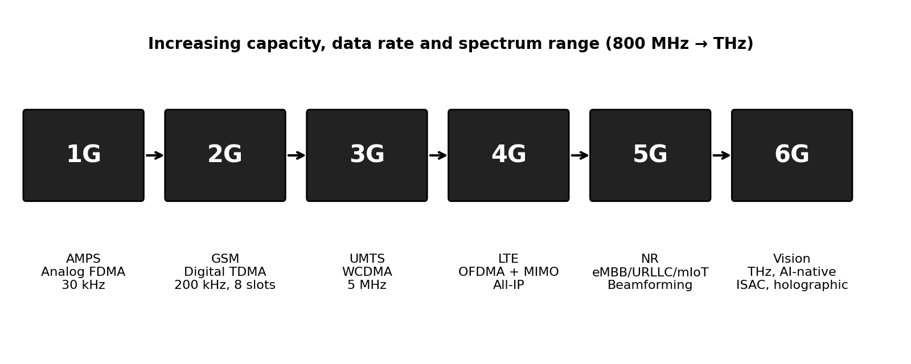
Figure 1: Evolution of mobile systems from 1G to the 6G vision
Calculations (Stage 1)
1. Wavelength at 800 MHz. λ = c / f = (3 × 10⁸ m/s) / (800 × 10⁶ Hz) = 0.375 m (37.5 cm).
2. Idealized number of 30 kHz channels in 10 MHz.
N = B_total / B_channel = 10 MHz / 30 kHz = 10,000 kHz / 30 kHz = 333.3 → 333 channels (rounded down)
Practical qualification. This result is idealized: it ignores guard bands between channels and at the band edges, and it ignores duplexing. AMPS is an FDD system in which each call needs one uplink and one downlink channel, so if the 10 MHz were split into two 5 MHz halves only about 166 two-way (duplex) channels would be available. Control/signalling channels also consume part of the total. Finally, because of frequency reuse (N = 7 in this study) a single cell can use only about 1/7 of the channels, i.e. roughly 333 / 7 ≈ 47 voice channels per cell. The figure 333 is therefore an upper bound, not a deployable capacity.
3. Why the 2G move to digital transmission and TDMA improved on 1G analog service. In AMPS one 30 kHz channel carries one call, i.e. 30 kHz per user. In GSM one 200 kHz carrier is divided in time into 8 TDMA slots, so 8 full-rate calls share a carrier: 200 kHz / 8 = 25 kHz per user, about 17% less spectrum per call before any other gain. The larger improvement comes from digital transmission itself: speech coding compresses voice, error-correcting codes and equalization let the receiver work at a much lower carrier-to-interference ratio (typically about 18 dB is quoted for AMPS but only about 9–12 dB for GSM), which allows smaller reuse clusters (more channels per cell). Digital signalling also enables encryption and authentication, SMS and data services, and a more efficient network and handoff control. TDMA also lets the handset use idle slots to measure neighbouring cells, supporting mobile-assisted handoff.
Synthesis paragraph (Stage 1)
Across the generations the main design question shifted from “how many voice channels can be carved out of the band” (1G FDMA, 30 kHz per user) to “how efficiently can a shared, interference-limited resource be reused”. 2G replaced analog FDMA by digital TDMA/FDMA, improving capacity and security and lowering the C/I needed. 3G made the 5 MHz carrier shared by all users through CDMA, so capacity became limited by interference and power control rather than by fixed channel counts, and soft handoff became possible. 4G LTE turned the problem into one of scheduling time-frequency resource blocks with OFDMA and exploiting the spatial dimension with MIMO, with interference managed by coordination between cells. 5G NR adds new spectrum (mid-band and mmWave), beamforming and service classes (eMBB, URLLC, massive IoT), so interference is managed in space as well as in frequency and time. The 6G vision extends this to THz bands, AI-native resource management and ISAC. Overall, spectrum moved from being a count of channels to a scarce resource whose value depends on bandwidth, propagation and reuse; capacity moved from channel count to spectral efficiency × bandwidth × cell density; and interference management moved from static reuse planning to dynamic, adaptive and increasingly AI-assisted control.
Stage 2 Analyze cell coverage and frequency reuse
Using the hexagonal planning model, calculate the area of one cell and the total area of the 19-cell cluster. For N = 7, calculate the frequency reuse fraction and the reuse distance D = r√(3N). Explain the assumptions behind the hexagonal approximation and distinguish geometric coverage from guaranteed radio coverage.
Explain how cell splitting, sectoring, microcells, picocells and femtocells can change coverage and capacity. Recommend a suitable capacity-expansion measure for the regional operator and identify its effects on interference and handoff frequency.

Answer – Stage 2: Cell coverage and frequency reuse
Calculations (Stage 2)
Inputs: hexagonal model, r = 2 km (centre-to-vertex), 19-cell cluster, reuse cluster size N = 7.
1. Area of one hexagonal cell.
A_cell = (3√3 / 2) r² = 2.598 × (2 km)² = 2.598 × 4 = 10.39 km²
2. Total area of the 19-cell cluster.
A_19 = 19 × 10.39 km² = 197.45 km²
3. Frequency reuse fraction for N = 7. Each cell uses 1/N of the total channels:
Reuse fraction = 1/N = 1/7 = 0.143 (≈ 14.3% of the channels per cell)
4. Reuse distance (distance between centres of nearest co-channel cells).
D = r√(3N) = 2 km × √(3 × 7) = 2 km × √21 = 2 km × 4.583 = 9.17 km (D/r = 4.58)
Interpretation. For a first-tier model with six co-channel interferers and path-loss exponent n = 4 (an assumed typical urban value), the signal-to-interference ratio is approximately C/I ≈ (D/r)ⁿ / 6 = 4.583⁴ / 6 = 441 / 6 ≈ 73.5 ≈ 18.7 dB. This shows why N = 7 is the classical choice for analog/FM systems that need about 18 dB, and it is a useful reference for the interference analysis in Stage 5.
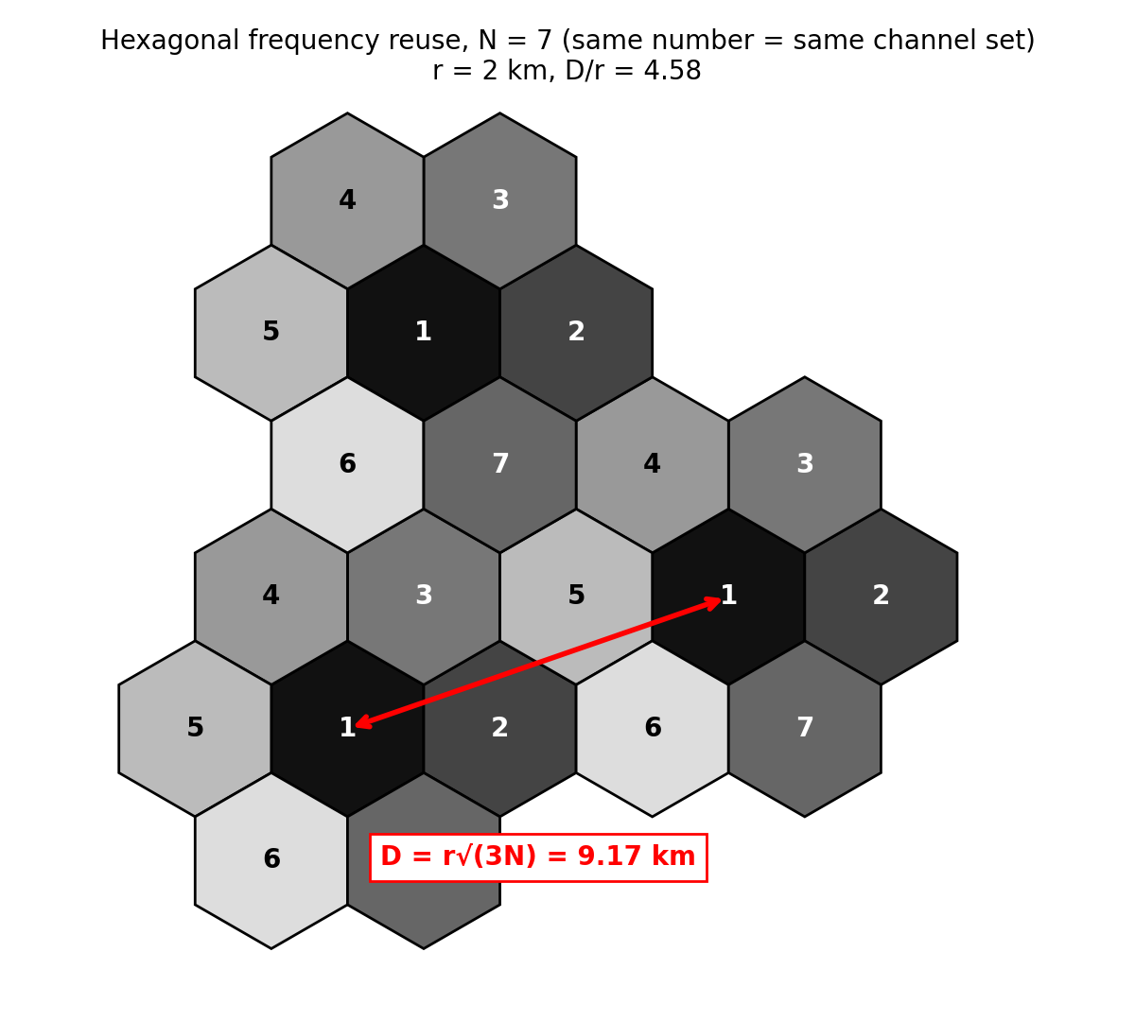
Figure 2: Hexagonal frequency reuse for N = 7 showing the reuse distance D
Assumptions behind the hexagonal approximation
The hexagon is used because it is the regular polygon closest to a circle that tiles the plane without gaps or overlaps, so the area and reuse geometry can be calculated simply. It assumes: a base station at the cell centre with an omnidirectional antenna; identical radius and transmit power in every cell; flat, homogeneous terrain with the same path-loss exponent everywhere; uniform user and traffic density; and a sharp cell boundary where the signal level is equal.
Geometric coverage versus guaranteed radio coverage. Geometric coverage is only the area of the idealized shape. Guaranteed radio coverage means that, at a stated percentage of locations and time, the received signal exceeds the required threshold (and the SINR is adequate). Real coverage is irregular because of terrain, buildings and foliage (shadowing), multipath fading, building penetration loss, antenna patterns and tilt, and interference from other cells. A location inside the hexagon may therefore have no usable service, and some service will exist outside it. Practical planning uses link budgets, fade margins, propagation models and drive tests rather than the hexagon alone.
Capacity-expansion techniques
Technique | How it changes coverage and capacity | Main side-effects
Cell splitting | Divides a congested cell into smaller cells with new base stations at lower power. Halving the radius divides the cell area by 4 (area ∝ r²), so about 4× as many cells, and therefore about 4× channel reuse and capacity in the same area. Transmit power can be reduced by about 10 n log₁₀(2) ≈ 12 dB for n = 4 so that D/r (and C/I) is unchanged. | More sites and backhaul cost; more handoffs (shorter cell crossing time); re-planning of frequencies and power
Sectoring | Replaces the omni antenna by 120° (or 60°) directional antennas. The number of first-tier co-channel interferers falls from 6 to about 2 (120°), improving C/I by up to ≈ 10log₁₀(3) ≈ 4.8 dB; that margin can be used to reduce N and gain capacity. | Channels are divided among sectors (trunking efficiency drops); more sector-to-sector (intra-site) handoffs; more antennas
Microcells | Low-power base stations (typically a few hundred metres range) on street furniture/lamp posts in dense urban areas; add capacity and fill street-level coverage. | Many sites, irregular coverage, mobility handoffs between small cells, interference with the macro layer
Picocells | Indoor or hotspot cells (tens of metres) in malls, stations, offices; add capacity where traffic is concentrated and improve indoor coverage. | Indoor planning/backhaul, interference leakage outdoors
Femtocells | Very small, user-installed home/office access points using broadband backhaul; offload traffic and improve indoor signal. | Uncoordinated placement can cause cross-tier interference; security/backhaul quality; need for self-configuration

Recommended capacity-expansion measure for the regional operator
Recommendation: 120° sectoring of the macro cells first, followed by selective cell splitting / microcells (and picocells indoors) only in the hot spots that actually exhaust capacity. The reasons are: (i) the Stage 3 result shows that the whole planning-area busy-hour demand (80 Erlangs) fits on 92 channels, so the present problem is coverage and interference rather than raw capacity; (ii) the Stage 5 result shows SINR of 13.8 dB, which is 1.2 dB short of the 15 dB target, and sectoring is the measure that directly reduces co-channel interference (≈ 4.8 dB improvement in the ideal case) while reusing existing sites; (iii) it defers the large cost of building many new sites until demand justifies it.
Effect on interference: sectoring reduces the number of co-channel interferers seen by each receiver and improves C/I; cell splitting keeps C/I the same only if power is scaled down and the reuse ratio D/r is preserved; micro/pico/femtocells add a new tier whose interference with the macro layer must be controlled by power control and frequency/time coordination. Effect on handoff frequency: sectoring adds more (mostly softer or intra-site) handoffs; halving the cell radius roughly doubles the handoff rate per moving call because crossing time halves; microcells give the highest handoff rates for fast users, so high-speed users should stay on the macro layer.

Stage 3 Estimate traffic capacity
Calculate the offered busy-hour traffic for the planning area. Find the Erlang B blocking probability with 100 channels, then determine the smallest channel count that meets the 2% target. Estimate how many 100-channel base-station channel groups are needed to serve that channel requirement, and state why this is only a first-order estimate rather than a complete site plan.
Explain the capacity, blocking and infrastructure trade-offs in your result. State at least one assumption behind the offered-traffic model.

Answer – Stage 3: Traffic capacity
Calculations (Stage 3)
Inputs: U = 1,000 subscribers; a = 0.08 Erlang per subscriber in the busy hour; initial base station C = 100 channels; blocking target B ≤ 2%.
1. Offered busy-hour traffic.
A = U × a = 1,000 × 0.08 Erlang = 80 Erlang
2. Erlang B model. For offered traffic A and C channels, with blocked calls cleared:
B(A, C) = (A^C / C!) / Σ_{k=0}^{C} (A^k / k!)
For numerical stability it is evaluated by the recursion B(A,0) = 1; B(A,k) = A·B(A,k−1) / [k + A·B(A,k−1)], which was run with a short script for k = 1 … 100.
3. Blocking with 100 channels. B(80, 100) = 0.00399 = ≈ 0.40%, which is well below the 2% target. The 100-channel base station carries 80 × (1 − 0.00399) = 79.7 Erlang, i.e. 79.7% channel utilization.
4. Smallest channel count meeting the 2% target.
Channels C | Blocking B(80, C) | Meets ≤ 2%? | Carried traffic / utilization
88 | 3.48% | No | 77.2 E / 87.7%
90 | 2.62% | No | 77.9 E / 86.6%
91 | 2.25% | No | 78.2 E / 85.9%
92 | 1.92% | Yes – smallest | 78.5 E / 85.3%
100 | 0.40% | Yes (over-provided) | 79.7 E / 79.7%

The smallest channel count is therefore C = 92 channels.
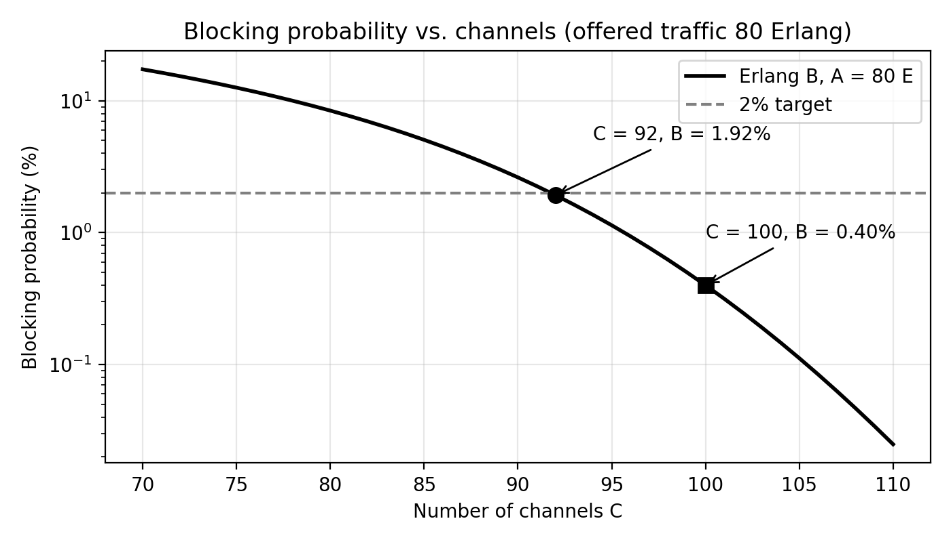
Figure 3: Erlang B blocking probability versus number of channels for 80 Erlang
5. Number of 100-channel base-station channel groups.
Groups = ⌈ 92 / 100 ⌉ = ⌈ 0.92 ⌉ = 1 group
One 100-channel base station is sufficient to serve the pooled demand with margin (8 spare channels). Solving the Erlang B equation in reverse, a 100-channel group can carry about 88 Erlang at 2% blocking, equivalent to about 88 / 0.08 ≈ 1,100 subscribers, so there is roughly 10% growth headroom.
Why this is only a first-order estimate
The calculation pools all traffic as if it were offered to one ideal group of channels. A complete site plan would also have to consider: the 197 km² planning area needs 19 cells for radio coverage, so the traffic is spread over many sites (if uniform, only 80/19 ≈ 4.2 Erlang per cell, which needs 9 channels per cell at 2% blocking, ≈ 171 channels in total versus 92 pooled, showing the loss of trunking efficiency when traffic is split); frequency reuse (each cell only has about 1/7 of the spectrum); non-uniform and moving traffic and hot spots; sectorization; control/signalling channels; handoff traffic; backhaul and equipment limits; traffic growth; and call retries.
Capacity, blocking and infrastructure trade-offs
Blocking falls steeply with extra channels (from 1.92% at 92 channels to 0.40% at 100 channels), but each additional channel gives diminishing returns and costs spectrum, radio hardware and backhaul. Pooling more channels in one group raises the achievable utilization (trunking efficiency): 92 pooled channels carry 78 Erlang at 85% utilization, whereas small groups carry far less traffic per channel at the same blocking. Larger groups are efficient but a single large site cannot provide the coverage, so the operator must balance coverage sites, capacity per site, and blocking target. Accepting a looser blocking target would reduce infrastructure but degrade user experience; a tighter target needs extra channels or additional cells.
Assumptions of the offered-traffic model: (1) call arrivals are random (Poisson) and independent; (2) call holding times are exponentially distributed (the Erlang B result is in fact insensitive to the holding-time distribution); (3) blocked calls are cleared and not retried (lost-calls-cleared); (4) all 1,000 subscribers are identical and generate 0.08 Erlang in the busy hour; (5) all 100 channels are available to every call (full availability) and none are reserved for handoff or control; and (6) the number of sources is large compared with the number of channels.
Stage 4 Evaluate mobility and handoff
Calculate the distance travelled during the 6 s overlap interval. Estimate hard handoffs per minute using the 1 km route cell length and supplied speed, stating how you interpret that length. Compare hard, soft and softer handoff in terms of connection continuity and resource use. Using the given interruption duration and 1% target-cell unavailability, estimate a simple call-drop risk for one handoff and explain the limits of that estimate.

Answer – Stage 4: Mobility and handoff
Calculations (Stage 4)
Inputs: v = 60 km/h; overlap dwell time t = 6 s; route cell length L = 1 km; handoff interruption = 0.5 s; target cell unavailable 1% of the time.
1. Speed in SI units. v = 60 km/h = 60 000 m / 3 600 s = 16.67 m/s.
2. Distance travelled in the 6 s overlap interval.
d = v × t = 16.67 m/s × 6 s = 100 m (10% of the 1 km route cell length)
This is the length of the overlap (handoff) zone that the network must be planned to provide.
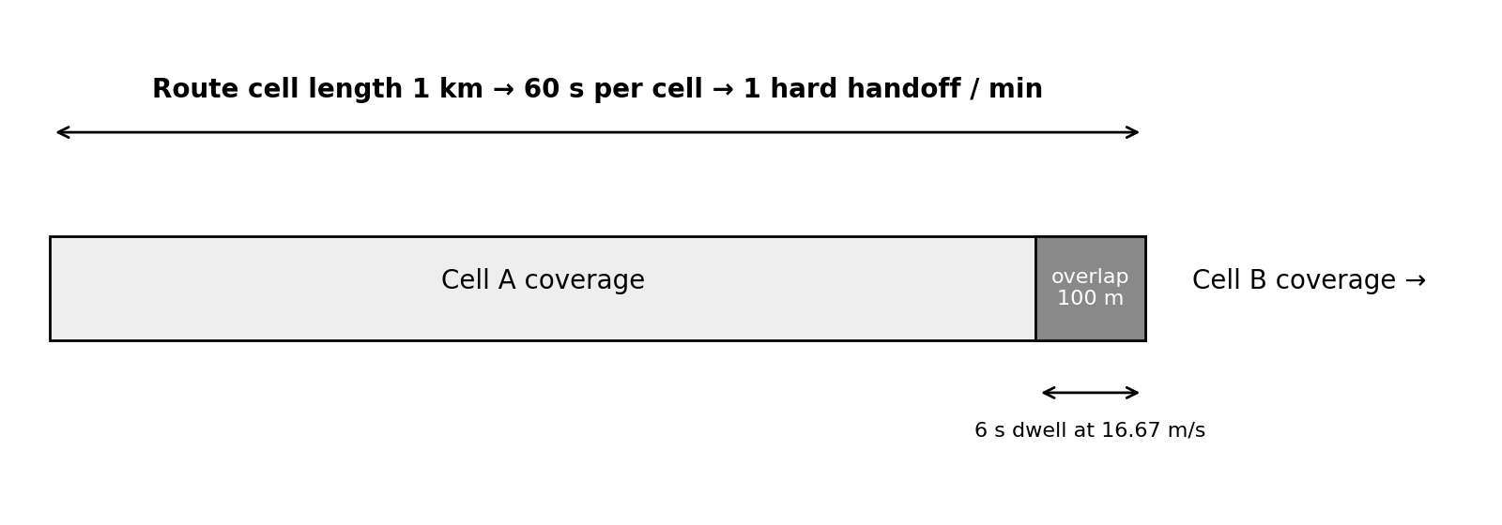
Figure 4: Handoff geometry – overlap zone and route cell length at 60 km/h
3. Hard handoffs per minute. Interpretation: the 1 km “nominal cell length along the route” is taken as the distance between successive handoff points, i.e. one cell is crossed per kilometre of route and one handoff occurs at each boundary.
Time per cell = L / v = 1 000 m / 16.67 m/s = 60 s → Handoff rate = 60 s / 60 s = 1 hard handoff per minute
Sensitivity: if the user were instead crossing the full hexagon (≈ 3.46 km across the flats or 4 km across the vertices for r = 2 km), the rate would be only about 0.29 or 0.25 handoffs per minute. The 1 km nominal value is therefore a conservative (high handoff-rate) planning figure. A smaller cell, such as after cell splitting or in microcells, increases this rate proportionally.
Comparison of hard, soft and softer handoff
Type | Connection continuity | Resource use | Typical use / comment
Hard handoff | Break-before-make: the old link is released before the new one is established, so there is a brief interruption (0.5 s here) and a risk of dropping the call if the target has no free channel | Uses one radio link at a time; no duplicated resources; simplest | AMPS, GSM, and LTE/NR style handover; needs good handoff-priority channel allocation
Soft handoff | Make-before-break: the mobile is connected to two or more cells (different base stations) at the same time, so there is essentially no interruption and a much lower drop risk | Uses extra channels/codes, backhaul and base-station processing in both cells during the handoff; combining at the controller | CDMA / UMTS (universal reuse); gives macro-diversity gain at cell edges
Softer handoff | Make-before-break between sectors of the same base station; signals from the sectors are combined in the same base station (e.g., rake receiver) | Uses extra resources only at that site; no extra backhaul or inter-site signalling | CDMA / UMTS sectored sites; simpler and cheaper than soft handoff

Simple call-drop risk estimate for one handoff
Model: the call is lost at a hard handoff if the target cell cannot supply a channel at that instant. With the target cell unavailable 1% of the time:
P_drop (one handoff) ≈ P(target unavailable) = 0.01 (1%)
The 0.5 s interruption is the time during which the user has no connection; it is only 0.5 / 60 = 0.83% of the time on a route that has one handoff per minute and is only 0.5 / 6 = 8.3% of the 6 s overlap window, so there is time for the handover command and a possible retry within the overlap zone. Because the 1% risk repeats at each handoff, the chance of at least one drop during a call of T minutes (one handoff per minute) is 1 − 0.99ᵀ: ≈ 4.9% for a 5-minute call and ≈ 9.6% for a 10-minute call. If one independent retry were possible within the overlap zone, the risk per handoff would fall to about 0.01² = 10⁻⁴, but this requires the optimistic independence assumption.
Limits of the estimate: it treats unavailability as a fixed, independent probability and so ignores real causes of drops (signal level falling below threshold in the overlap area, handoff margin/hysteresis settings, ping-pong handoffs, shadowing, signalling delay, speed variations); it ignores handoff-priority measures such as guard channels that reduce the dropping probability below the blocking probability; it ignores load variations in the target cell; and it assumes a constant speed on a straight route with one neighbour. It is a first-order indicator for comparing options, not a prediction of the actual drop-call rate.
Stage 5 Quantify interference and compare spectrum bands
For the interference case, calculate the carrier-to-interference ratio using the co-channel interferer alone. Then sum co-channel and adjacent-channel interference in linear power units, convert the total back to dBm, calculate SINR, and decide whether the 15 dB target is met. Recommend one suitable mitigation and explain its likely trade-off.
For 900 MHz, 3.5 GHz and 28 GHz, calculate wavelength and free-space path loss at 100 m, including path-loss differences relative to 900 MHz. Compare likely penetration, antenna size and coverage/capacity implications. Explain why the higher path loss at higher frequencies does not by itself determine achievable network performance.

Answer – Stage 5: Interference and spectrum-band comparison
Calculations (Stage 5A) – Interference case
Inputs: S = −70 dBm; co-channel I₁ = −85 dBm; adjacent-channel I₂ = −90 dBm; required SINR ≥ 15 dB.
1. Carrier-to-interference ratio with the co-channel interferer alone.
C/I = S − I₁ = −70 dBm − (−85 dBm) = 15 dB (a power ratio of 31.6)
The result exactly equals the 15 dB target, so there is zero margin even before the adjacent-channel signal and noise are included.
2. Sum the interference in linear power units (dB values cannot be added directly).
I₁ = 10^(−85/10) mW = 10^(−8.5) = 3.162 × 10⁻⁹ mW
I₂ = 10^(−90/10) mW = 10^(−9.0) = 1.000 × 10⁻⁹ mW
I_total = I₁ + I₂ = 4.162 × 10⁻⁹ mW
I_total (dBm) = 10 log₁₀(4.162 × 10⁻⁹) = −83.81 dBm
3. SINR. No thermal-noise value is supplied, so the noise term is neglected (the result is interference-limited and any real noise would make it lower):
SINR = S − I_total = −70 − (−83.81) = 13.81 dB
4. Decision. 13.81 dB < 15 dB, so the target is NOT met; the shortfall is 1.19 dB (the total interference must be at least 1.19 dB lower). Equivalently, the combined interference must not exceed −85 dBm, which requires, with I₂ unchanged, I₁ ≤ −86.65 dBm (a 1.65 dB reduction of the co-channel level).
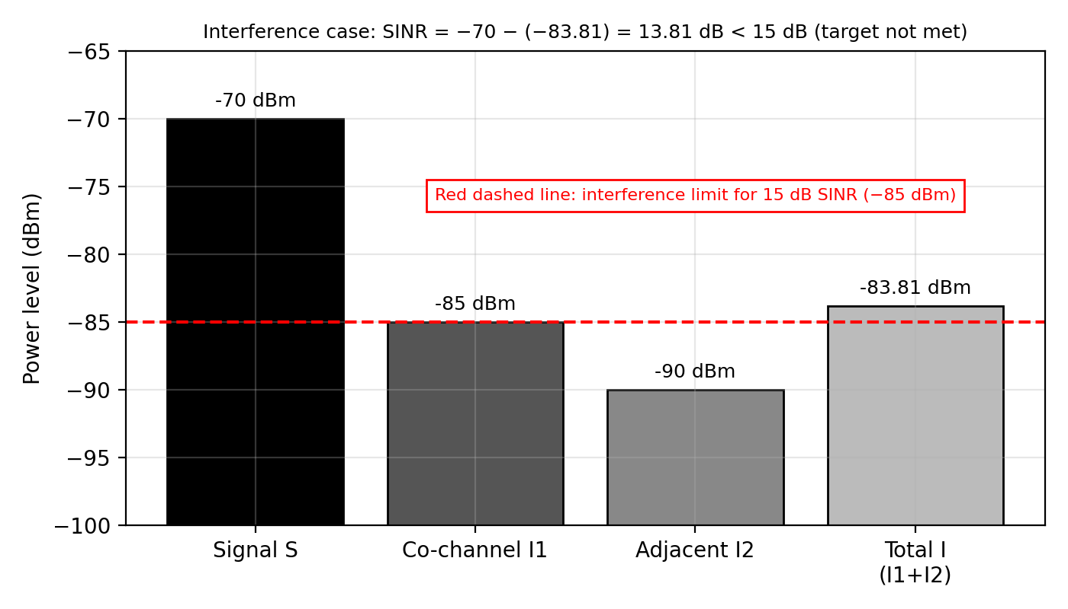
Figure 5: Signal and interference levels, total interference and SINR check
Recommended mitigation and trade-off
Recommendation: 120° sectoring with antenna down-tilt (and power control) at the co-channel sites. Sectoring cuts the number of co-channel interferers seen by each receiver from about six to about two, i.e. up to ≈ 4.8 dB reduction of the co-channel term. Applying 4.8 dB to I₁ gives I₁ ≈ −89.8 dBm; adding I₂ = −90 dBm gives I_total ≈ −86.9 dBm and SINR ≈ 16.9 dB, which exceeds the 15 dB target by about 1.9 dB (an ideal-case value; practical improvement is usually a little smaller because of antenna side-lobes and back-lobes). Trade-off: the channels of each cell are divided among three sectors, which lowers trunking efficiency (more channels needed for the same blocking), and there are more handoffs between sectors, more antennas and higher site cost. Alternatives are a larger reuse cluster (e.g. N = 7 → 12), which also improves C/I but cuts channels per cell by about 42%, or better filtering/guard bands for the adjacent-channel term, which sacrifices spectrum.
Calculations (Stage 5B) – Spectrum-band comparison at d = 100 m
Equations: λ = c / f with c = 3 × 10⁸ m/s; FSPL (dB) = 20 log₁₀(4πd/λ); difference relative to 900 MHz ΔFSPL = 20 log₁₀(f / 900 MHz).
Frequency | Wavelength λ | 4πd/λ | FSPL at 100 m | Δ vs 900 MHz
900 MHz | 0.3333 m (33.3 cm) | 3 770 | 71.53 dB | 0 dB (reference)
3.5 GHz | 0.0857 m (8.57 cm) | 14 660 | 83.32 dB | +11.80 dB
28 GHz | 0.0107 m (1.07 cm) | 117 286 | 101.38 dB | +29.86 dB

Example: at 900 MHz, 4π × 100 / 0.3333 = 3 770, and 20 log₁₀(3 770) = 71.53 dB. Moving from 900 MHz to 3.5 GHz increases the free-space loss by 11.8 dB (a factor of about 15 in power), and to 28 GHz by 29.9 dB (a factor of about 970 in power).
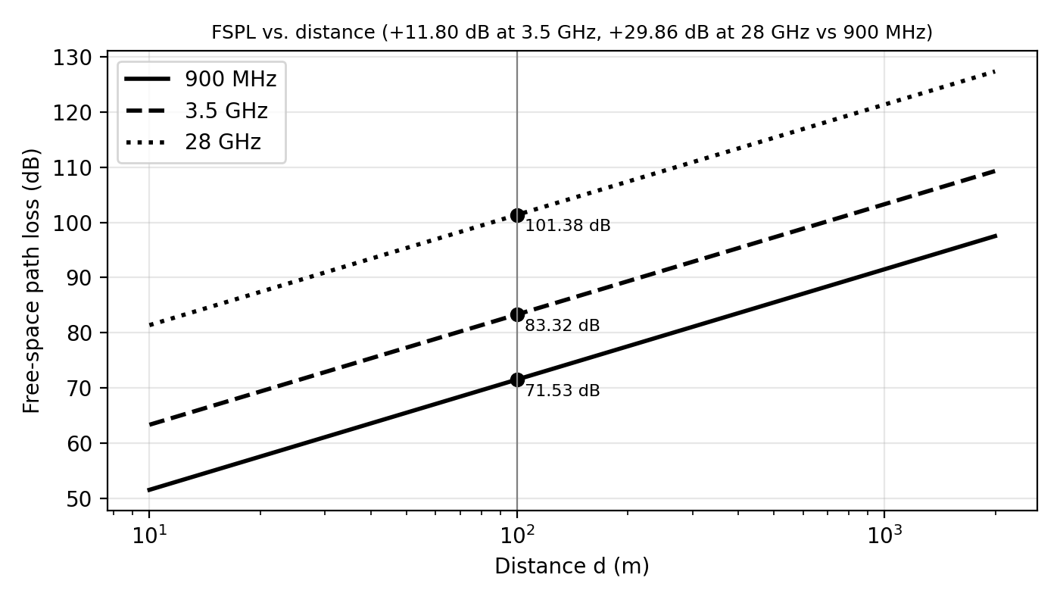
Figure 6: Free-space path loss versus distance for 900 MHz, 3.5 GHz and 28 GHz
Comparison of penetration, antenna size and coverage/capacity
Aspect | 900 MHz | 3.5 GHz | 28 GHz
Penetration (walls, vegetation, body) | Best – good indoor and obstructed penetration; diffracts around obstacles | Moderate – adequate for outdoor and light indoor, weaker through thick walls | Poor – strongly blocked by walls, glass coatings, foliage, rain and the human body; mostly line-of-sight
Antenna size (half-wave element) | ≈ 16.7 cm; large for arrays | ≈ 4.3 cm; many elements (massive MIMO) fit in a panel | ≈ 0.54 cm; very large arrays (tens/hundreds of elements) fit in a small module
Coverage | Widest – suits macro cells, rural and wide-area coverage (fewest sites) | Medium – needs more sites or beamforming gain to match 900 MHz coverage | Smallest – range typically hundreds of metres or less; dense small cells needed
Capacity | Lowest – narrow bandwidth is usually available (a few MHz to tens of MHz) | High – wide channels (up to ~100 MHz) per operator; the main 5G capacity layer | Highest – very wide channels (hundreds of MHz) give multi-Gb/s peak rates and high capacity per area
Typical role | Coverage layer (deep indoor, rural, IoT) | Capacity-coverage balance for urban/suburban | Hotspot, FWA and venue capacity layer

As a first-order scaling, for a path-loss exponent n = 3.5 the 11.8 dB extra loss at 3.5 GHz shrinks the range by a factor 10^(11.8/35) ≈ 2.2 (e.g. 2 km → ≈ 0.9 km), and the 29.9 dB extra loss at 28 GHz shrinks it by ≈ 7.1 (2 km → ≈ 0.28 km), unless it is compensated by antenna/beamforming gain.
Why higher path loss does not by itself determine network performance
(1) The free-space formula assumes isotropic antennas at both ends. The gain of an antenna of fixed physical area increases as 1/λ², so the same size antenna panel provides 11.8 dB more gain at 3.5 GHz and 29.9 dB more at 28 GHz than at 900 MHz. With beamforming/massive MIMO, the extra loss can therefore be largely recovered; indeed, for fixed-size antennas at both ends the free-space received power does not fall but rises with frequency. (2) Throughput depends on bandwidth and SINR (Shannon: C = B log₂(1 + SINR)), not on path loss alone: for example at SINR = 13.8 dB (24×), the spectral efficiency bound is about 4.6 bit/s/Hz, which gives about 93 Mb/s for 20 MHz but about 1.9 Gb/s for 400 MHz, so the wide bandwidths at higher frequencies can outweigh their higher loss. (3) Higher frequencies are also more directional, which reduces interference and permits high spatial reuse. (4) Real performance is also determined by blockage and penetration, interference, noise power (which increases with bandwidth), load, handoff behaviour, backhaul, device capability and spectrum availability. Path loss is thus one input to the link budget, not the final measure of performance.
Stage 6 Explain spectrum coordination and make a deployment recommendation
Describe the distinct roles of ITU-R, the World Radiocommunication Conference (WRC) and the Radiocommunication Bureau (BR) in international spectrum coordination. Explain one way international coordination affects national regulators and operators.
Conclude with a recommended staged strategy for the regional network. Your recommendation must connect generational evolution, the calculated cell and traffic plan, handoff behavior, interference results, and spectrum-band characteristics. Identify the most important assumptions or uncertainties that should be checked before deployment.

Answer – Stage 6: Spectrum coordination and deployment recommendation
Roles in international spectrum coordination
Body | Distinct role | Example of its effect
ITU-R (ITU Radiocommunication Sector) | The sector of the International Telecommunication Union (a UN agency) responsible for global radio-frequency spectrum and satellite-orbit management. Through its study groups it develops technical Recommendations and reports, the vision/requirements for IMT (3G/4G/5G/6G) systems, and the sharing/compatibility studies on which allocation decisions rest. | Defines the IMT framework (IMT-2000, IMT-Advanced, IMT-2020, IMT-2030) and the technical conditions that national regulators use when planning mobile bands
WRC (World Radiocommunication Conference) | The decision-making conference of ITU member states, normally held every three to four years. It reviews and revises the Radio Regulations (an international treaty): the Table of Frequency Allocations, identification of bands for services such as IMT, and technical/regulatory provisions, according to an agreed agenda. | A WRC decision can identify a band for IMT, or add conditions to protect other services such as satellite or radio astronomy
BR (Radiocommunication Bureau) | The executive/administrative arm of ITU-R, headed by an elected Director. It applies the Radio Regulations: processes notifications and coordination requests for frequency assignments and satellite networks, records them in the Master International Frequency Register, supports the study groups and conferences, and helps resolve harmful-interference cases. | Gives international recognition and protection to registered assignments, and a formal procedure for cross-border coordination

One way international coordination affects national regulators and operators: national regulators generally align their national frequency tables and licences with the Radio Regulations and WRC identifications, because harmonized bands give device and equipment economies of scale and easy roaming, while the regulator and operators must comply with cross-border rules. In practice a licence for 3.5 GHz or 28 GHz carries conditions (power-flux-density or out-of-band-emission limits, protection of satellite earth stations and of neighbouring countries near borders, and bilateral coordination agreements). The operator must therefore design its network (power, tilt, sectoring, guard bands) to meet these obligations, and cannot assume that a band available in the ITU tables is freely usable nationally.
Recommended staged deployment strategy for the regional network
Phase | Action | Evidence from the analysis | Main risk to check
Phase 1 – Coverage foundation | Deploy/upgrade the 19-cell macro layer (≈ 197 km², r = 2 km) on the sub-1 GHz (900 MHz) band using LTE/5G-NR-capable radios with 120° sectors and down-tilt, N = 7 reuse; use one 100-channel (≥ 92 channels) capacity group per the pooled estimate and keep ≥ 8 spare channels | 900 MHz has the lowest FSPL (71.5 dB at 100 m) and best penetration; Stage 3 shows 92 channels give 1.92% blocking (A = 80 E) and 100 channels give 0.40%; sectoring lifts SINR from 13.8 dB to ≈ 16.9 dB (target 15 dB); D = 9.17 km for N = 7 | Real coverage vs hexagon (shadowing, terrain); traffic distribution per cell (≈ 4.2 E per cell if uniform); available 900 MHz bandwidth
Phase 2 – Capacity layer | Add 3.5 GHz (mid-band) massive-MIMO 5G NR on the busiest/urban sites when demand approaches ~88 E per 100-channel group (≈ 1,100 subscribers) or blocking exceeds 2%; use cell splitting/microcells where needed | +11.8 dB loss compensated by beamforming gain, wider bandwidth gives higher capacity; halving radius quadruples cell count and capacity | Site density/cost, backhaul, handoff rate rising as cells shrink (1 handoff/min at 1 km), interference with Phase 1 layer
Phase 3 – Hotspots / mmWave | Deploy 28 GHz pico/micro cells and fixed wireless access in stations, campuses, venues and dense hot spots; add indoor picocells/femtocells where indoor demand needs it | 28 GHz offers hundreds of MHz bandwidth but +29.9 dB loss (101.4 dB at 100 m), poor penetration and short range (~0.3 km) | Line-of-sight/blockage, beam management, device availability, national 28 GHz licence status and satellite coexistence
Phase 4 – Evolution | Introduce AI-based self-optimization (SON), interference coordination, URLLC/IoT slices and trials of ISAC/6G features as standards mature | 6G vision (THz, AI-native, ISAC) is not yet standardized | Standards, spectrum identification at future WRCs, energy cost

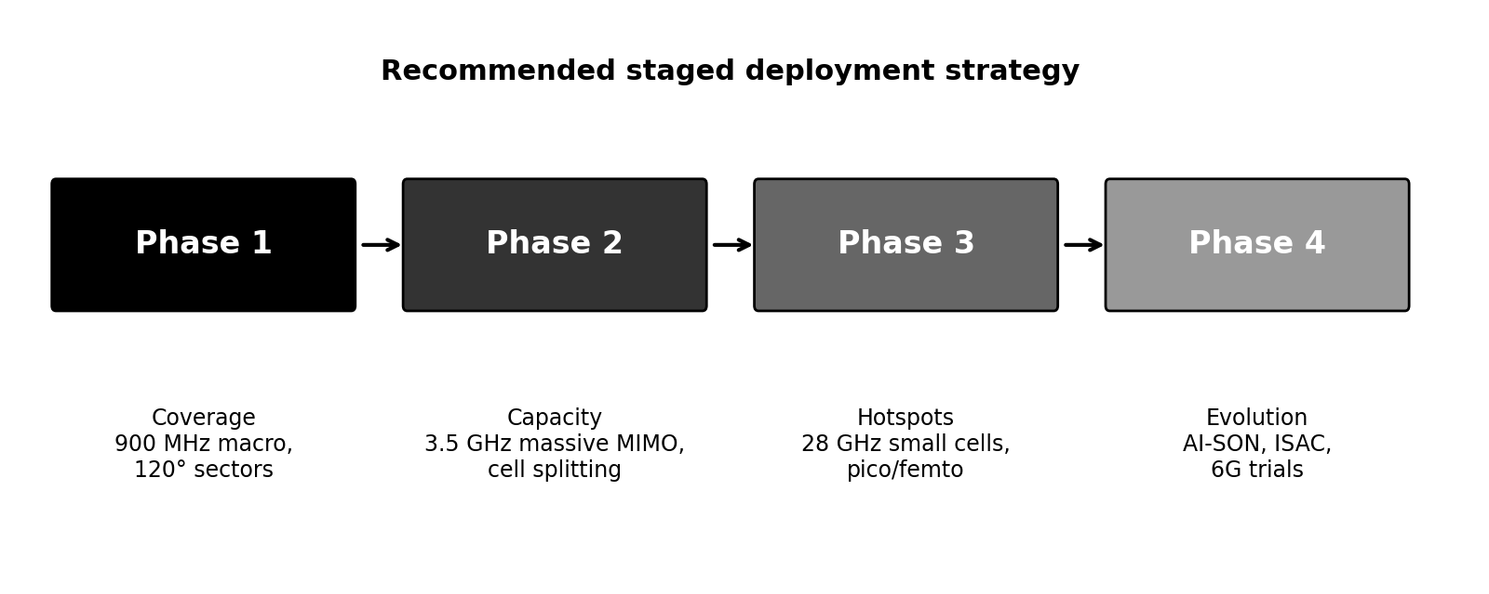
Figure 7: Recommended staged deployment strategy
Integration of the results. The generational study shows that capacity now comes from spectral efficiency × bandwidth × cell density, which is why the plan combines a low band for coverage, a mid band for capacity and mmWave for hot spots. The cell and traffic calculations show that the area needs 19 cells for coverage, but demand (80 Erlang, 92-channel requirement) is within a single 100-channel group, so the first investment should go to coverage and interference control rather than to new sites. The handoff analysis (100 m overlap, 1 handoff/min, ≈ 1% drop per handoff) shows that mobility is manageable at 60 km/h in 1 km cells but that handoff load and drop risk increase as cells get smaller, so high-speed users should remain on the macro layer and soft/softer handoff, guard channels or dual connectivity should be used where available. The interference calculation (SINR 13.8 dB < 15 dB) shows that the initial layout fails the target by 1.2 dB and needs sectoring/down-tilt or power control before launch. The spectrum comparison provides the layering logic, and ITU-R/WRC/BR coordination decides which of those bands may legally be used and under what conditions.
Key assumptions and uncertainties to check before deployment
1. Propagation: free-space and hexagonal assumptions are idealized; the path-loss exponent, shadowing margin and indoor penetration loss must be measured (drive tests/planning tool) to confirm cell radius, especially at 3.5 GHz and 28 GHz.
2. Traffic: 0.08 Erlang per subscriber, uniform density, Poisson arrivals and blocked-calls-cleared are assumptions; actual busy-hour demand, growth, data traffic (not just voice) and hot-spot distribution should be verified.
3. Interference: the SINR of 13.8 dB ignores thermal noise, shadowing and fading, and uses single co-channel and adjacent-channel values; real interference varies with load and with the number of co-channel cells, so the improvement from sectoring must be verified by measurements.
4. Mobility: the 1% target-cell unavailability and 1 km route cell length are nominal; real handoff margins, speed profiles and signalling delays could change the drop risk.
5. Spectrum and regulation: availability, bandwidth and licence conditions of 900 MHz, 3.5 GHz and 28 GHz in the operator’s country, international/cross-border coordination and satellite coexistence, and device-ecosystem support.
6. Economics and technology: site acquisition, backhaul and energy costs, equipment availability and standard timelines (including the 6G vision).
References
[1] T. S. Rappaport, Wireless Communications: Principles and Practice, 2nd ed., Prentice Hall, 2002 – cellular concepts, frequency reuse, trunking and Erlang B, handoff, path loss.
[2] V. H. MacDonald, “The Cellular Concept,” Bell System Technical Journal, vol. 58, no. 1, 1979.
[3] ITU-R, Radio Regulations (current edition), and ITU-R Recommendation M.2083 (IMT Vision – framework and overall objectives of IMT-2020) and M.2160 (IMT-2030 framework).
[4] 3GPP Technical Specifications on GSM, UMTS, LTE and NR (Releases 99, 8 and 15 onwards) – generation features.
[5] A. Goldsmith, Wireless Communications, Cambridge University Press, 2005 – free-space path loss and Shannon capacity.
[6] H. T. Friis, “A Note on a Simple Transmission Formula,” Proc. IRE, 1946.

Submission requirements
Submit one engineering design report. Organize it as: requirements → analysis → calculations → comparison → recommendation. Include equations and units, clearly labeled tables or diagrams where useful, assumptions, and brief interpretations alongside numerical results. Cite any external technical sources used. Software output without a description of the method and engineering meaning is insufficient.
Assessment rubric
Assessment criterion | Marks | Primary Bloom level
Generational evolution and interpretation of CO1 concepts | 15 | K4
Cell geometry, reuse and capacity-expansion analysis | 15 | K4 / K5
Traffic and channel-capacity calculation | 15 | K4 / K5
Mobility and handoff analysis | 15 | K4 / K5
Interference calculations and mitigation reasoning | 20 | K4 / K5
Spectrum-band comparison, ITU coordination and integrated recommendation | 20 | K5 / K6
TOTAL | 100

Performance expectations
Excellent | Good | Satisfactory | Needs improvement
Synthesizes CO1 concepts, calculates accurately, states assumptions, and defends an integrated deployment recommendation with evidence. | Uses sound methods and gives a supported recommendation, with minor calculation or explanation gaps. | Completes the main calculations but gives limited interpretation or weak connections among topics. | Relies on unsupported statements or tool output; major concepts, calculations or engineering reasoning are missing.

Consolidated Question

A regional wireless operator is planning the next stage of its mobile network. Using the planning data provided, prepare an evidence-based engineering report that explains the evolution of mobile systems from 1G through the 6G vision; analyzes cell coverage, frequency reuse, traffic demand, channel capacity, mobility, and handoff performance; calculates and interprets the effects of co-channel and adjacent-channel interference; compares the propagation and deployment implications of 900 MHz, 3.5 GHz, and 28 GHz; and explains how international spectrum coordination affects deployment. Conclude with a justified, phased network plan that connects your calculations and analysis, identifies relevant trade-offs, and states the assumptions and uncertainties that should be checked before implementation.

Answer – Consolidated Question: Summary report
Requirements → analysis → calculations → comparison → recommendation (summary). The operator needs a phased plan for a 19-cell area (r = 2 km, 197.45 km²) serving 1,000 subscribers (80 Erlang), with ≤ 2% blocking, 60 km/h mobility, SINR ≥ 15 dB, and a choice among 900 MHz, 3.5 GHz and 28 GHz. The table below summarizes the calculated results; the detailed method, equations and interpretation are given in the stage answers above.
Item | Result | Engineering meaning
Wavelength at 800 MHz; idealized 1G channels | 0.375 m; 10 MHz / 30 kHz = 333 channels (guard bands and duplexing ignored) | Upper bound only; ≈ 166 duplex pairs and ≈ 47 per cell at N = 7
Cell area / 19-cell area | 10.39 km² / 197.45 km² | Coverage needs 19 sites
Reuse fraction; reuse distance (N = 7) | 1/7 = 0.143; D = 9.17 km (D/r = 4.58) | ≈ 18.7 dB ideal C/I for n = 4
Offered traffic; blocking at C = 100 | 80 Erlang; 0.40% | Target of ≤ 2% met
Smallest C for ≤ 2% blocking; groups needed | 92 channels (1.92%); 1 group of 100 | ≈ 10% headroom (about 88 E per group)
Distance in 6 s; handoff rate; drop risk | 100 m; 1 per minute (1 km cell); ≈ 1% per handoff | ≈ 4.9% over a 5-minute call
C/I (co-channel only); total interference; SINR | 15 dB; −83.81 dBm; 13.81 dB | Target (15 dB) NOT met by 1.19 dB → mitigate (sectoring ≈ 16.9 dB)
FSPL at 100 m: 900 MHz / 3.5 GHz / 28 GHz | 71.53 / 83.32 / 101.38 dB (+11.80 and +29.86 dB) | Coverage layer / capacity layer / hot-spot layer

Final recommendation. Build a layered, phased network: (1) a 900 MHz sectored macro layer that provides coverage over the 19 cells, meets the 2% blocking target with at least 92 channels, and reaches the 15 dB SINR target through 120° sectoring and down-tilt; (2) a 3.5 GHz massive-MIMO capacity layer added where demand grows; (3) 28 GHz small cells for hot spots; and (4) preparation for 6G-era AI-native and ISAC features. Each phase should be confirmed against the assumptions and uncertainties listed in Stage 6, and each band must be used in accordance with ITU-R/WRC allocations and the national licence and cross-border coordination conditions.

